

Christmas Scavenger Hunt

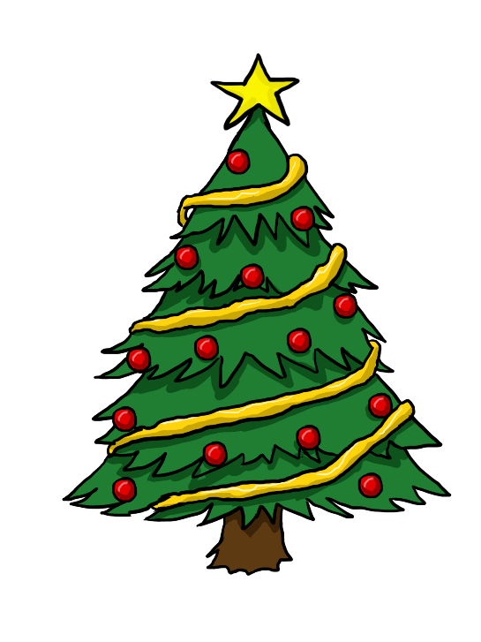

Clue #2

I’m big on bottom small on top  
  
And kinda hard to cuddle  
And if I stay out in the sun  
I’ll be nothing but a puddle!  
  
So make me out of snow or find me on a christmas tree  
Dont forget to take a picture and post for everyone to see

Send a photo of your answer to [mary.leben@gmail.com](mailto:mary.leben@gmail.com)