Our Lady of Guadalupe Fundraiser

Knights of Columbus Scholarship Program

***SAVE THE DATE***

*Saturday*

*November 4, 2017*

*Doors open at 5:00pm*

*Dinner at 6:00pm*

*Post Time at 7:00pm*

*Our Lady of Guadalupe*

*9080 Shepard Rd.*

*Macedonia, Ohio 44056*

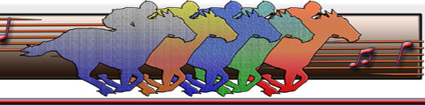

*Racers Post your horse!*

*Bettors place your bets.*

*Join us for an evening you will not soon forget.*

*Lucky Guests will have a chance to win Tower of Booze, Side Boards, Lottery Board and Racing wagers so invite*

*all your friends.*

*Winners of a Sponsored horse will receive $40 if their horse comes in 1st. Place.*

*.*

*This adult event is open to everyone, so invite 8 friends and reserve a table.*

*Spread the Word.*

*Tickets include Dinner catered by Robesto"s Catering, Pop, Beer, and dessert.*

*BYOB and Appetizers*

**RESERVE YOUR TICKETS TODAY!**

Name_____________________________________________

Address___________________________________________

City_____________________________State______________

Email_____________________________________________

______Race Night Ticket $20 Table of 8 is $150

If purchasing a table of 8 please list names on back

Ticket includes dinner, pop, beer, dessert

_____Purchase a horse $20 (If you want more than one horse list names on back).

Horse name__________________________________

_____Sponsor a Race $25 (advertising in booklet at top of race)

_____Best Value Package $50

2 tickets/1 horse

_____Single package $35

1 ticket/1 horse

_____Program Advertising

Business card size $25

Half page ad $50

Full page ad $75

$______Total

Make checks payable to OLG (Put Night at the Races in Memo)

Reservations can be submitted with check to the office.

Contact Mary Leben at 330.467.9305 with questions.