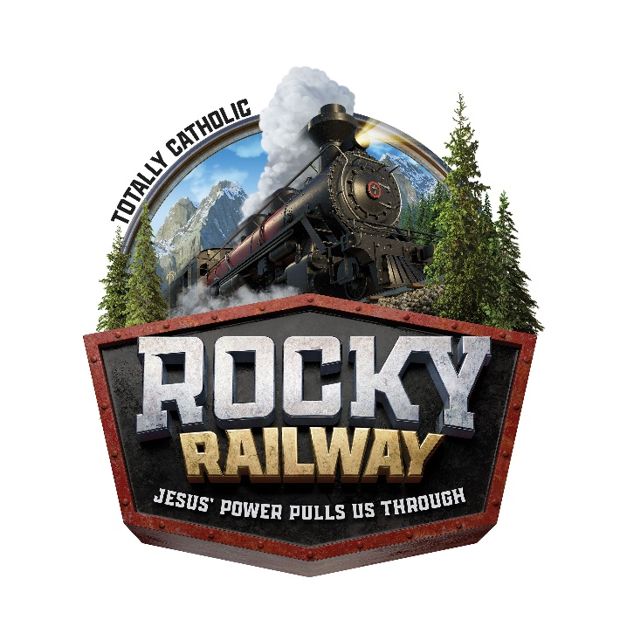

VBS is back!! Join us this summer as Our Lady of Guadalupe invites children (preschool-grade 4) to Rocky Railway VBS: Jesus’ power pulls us through from July 12 to July 16, from 9AM to NOON each day. At Rocky Railway, kids discover through life’s ups and downs that Jesus’ power pulls us through. Kids participate in memorable Bible-learning activities, sing catchy songs, play teamwork-building games, engage in fun snack-eating experiences, take part in one-of-a-kind Bible Adventures, collect Bible Memory Buddies to remind them to trust Jesus, and test out Sciency-Fun Gizmos they’ll take home and play with all summer long. Plus, kids will learn to look for evidence of God all around them through something called God Sightings. Each day concludes with the Rock Wrap-Up that gets everyone involved in living what they’ve learned.
To register, complete the registration form in the bulletin or click the link below that will take you to a pdf form to print. Then turn in the form with payment to the main office with attention to VBS.
When: July 12-16, 9AM-NOON
Where: Our Lady of Guadalupe Church
Who: Children (preschool- grade 4)
Cost: $10 per child

