Ash Wednesday/Lent 2022/Our Lady of Guadalupe Church, Macedonia, Ohio
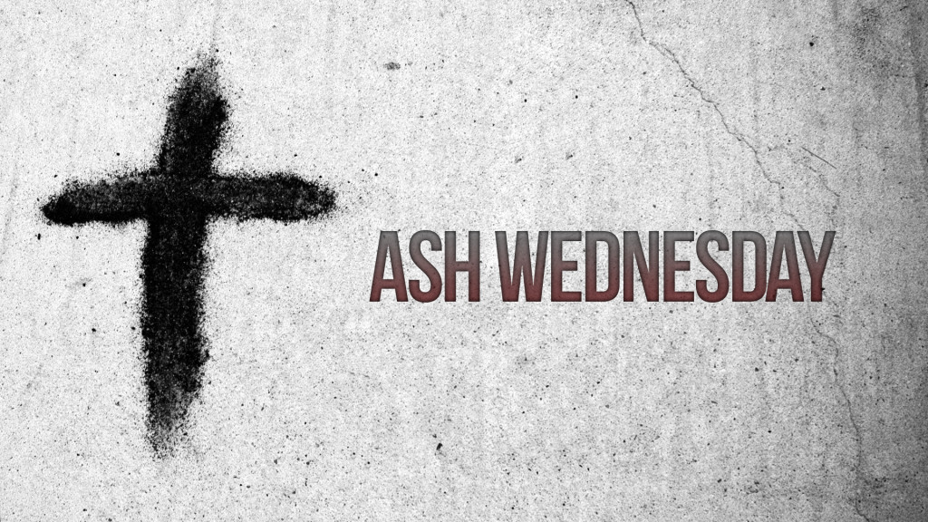
Dear Friends,

Doing Penance
Masses on Ash Wednesday with distribution of ashes at noon and 6.30 pm

As we receive ashes on our heads this day to begin the most holy season of Lent, we are set on a course of conversion. Our hearts must be changed and opened to Christ’s grace. Ashes are just a beginning. This is not a magical ritual! The ritual shows our intention to begin anew. Our intention is fulfilled in the Sacrament of Penance and celebrated in the death and resurrection of Jesus at the Easter Eucharist.
The Sacrament of Penance is a mystery at the center of the season and the Church's life. As a Mystery, the Sacrament expresses the Church's life. Although not fully understood, faith is needed to place the Sacrament at the center of our lives as followers of Jesus and our Parish. Even those who participate regularly fail to understand Christ's love in the Sacrament and the action of the Church. In the Sacrament of Penance, the Church in the Holy Spirit mystically presents the mercy of Christ and the Church. In the Sacrament, Priests are "Alter Christus," drawing the Church the heart of the One they represent. Christ and the Church is mercy. If a community fails to show mercy, the Church fails in its mission which often means the neglect of the Sacrament.
On this first day of Lent, the gospel of Matthew 6. 1, ff outlines penance. They are acts of mercy, prayer, and fasting. Penances are done to raise the poor. They are not primarily ways to care for ourselves. Penance are deeds of love for others. In turn we gain remission of sins and create compassionate hearts and a culture of mercy.
Please try to celebrate Penance/Confession during this season.
Individual Confessions are heard at 5.30pm on Mondays and Saturdays.
Diocesan Evening of Confession is on March 16 from 5-7:30 pm
Our Communal Penance with St. Barnabas Church is at Our Lady of Guadalupe Church on April 11 at 7pm.

On Monday March 7 following the 6.30 pm Mass, we will meet as a faith community in Church to reflect on Confession. Please gather with me and share your opinions and insights!
May prayers for you and your family,
Father Kevin Shemuga
Pastor

